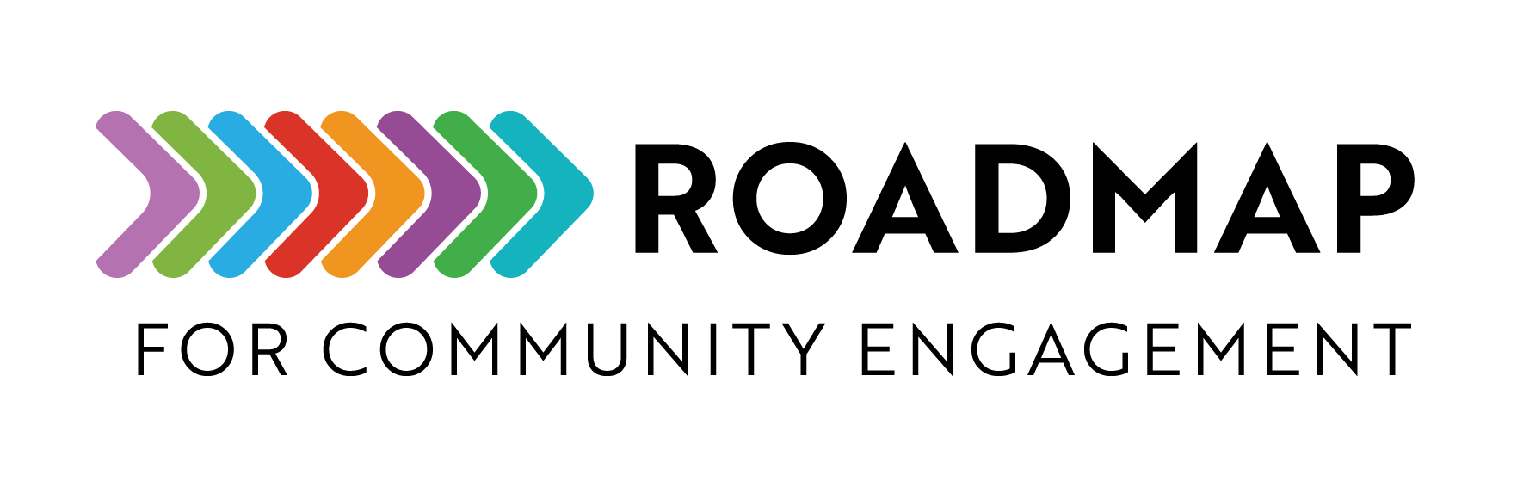

SMART Goals Template
This document explains how to create program goals that are clear, actionable, and achievable by ensuring that they are specific, measurable, achievable, relevant and time bound.

SMARTIE Goals: To include an Inclusion and Equity component to your goals, you can make sure your organization’s commitment to racial equity and inclusion is anchored by tangible and actionable steps—there’s a great resource located here: https://www.managementcenter.org/resources/smartie-goals-worksheet/

Instructions: Discuss and complete this SMART Goals Template with your partners.

Add your own logo or other graphic and remove this text box before sharing. Feel free to delete this text box before using or sharing!

Goal Statement
Write your main goal here. (What do you want to accomplish?)

S – Specific
- What exactly do I want to achieve?
- Why is this goal important?
- Who is involved?
- Where will this happen?
- Which resources or limits are involved?

M – Measurable
- How will I measure progress?
- What indicators will show that I’ve reached my goal?
- What are the milestones or targets along the way?

A – Achievable
- Is this goal realistic given my current resources and constraints?
- What steps are required to reach it?
- Do I have the skills and tools I need, or do I need to get them?

R – Relevant
- Why does this goal matter right now?
- How does it align with my personal, team, or organizational priorities?
- What will happen if I do not achieve this goal?
T – Time-Bound  - What is my target completion date?  - What are the key deadlines or checkpoints?  - Start Date:  - Target Completion Date:
  Step# | Task Description | Person Responsible | Deadline | Status

