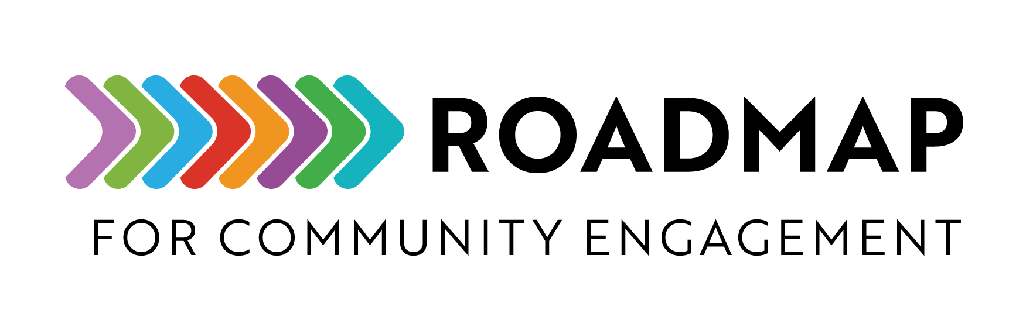

Communications Plan Example
This is an example of a communications plan for a community-engaged research program. It may help in developing your own communications plan.
Instructions:
- Use this example to help guide your communications planning.
- Use the Communications Plan Template to fill in your program specific plans

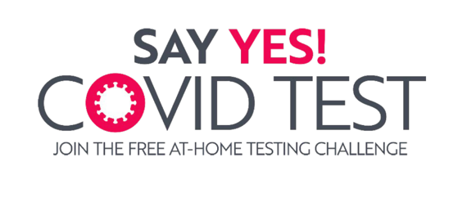

Communications Plan

Table of Contents
Goal/Objectives 2
Audiences 2
Branding and Messaging 2
Tone and Voice 2
Branding 2
Key Messages 2
Example of Communication Channels, Timing, Frequency, & Evaluation 3

Goal/Objectives
The purpose of this communications plan is to maximize outreach to the communities served and to support distribution of free COVID-19 test kits to communities.
The public information campaign aims to achieve the following objectives:
- Outreach to community about importance of testing and availability of free test kits
- Support distribution of test kits at community events
- Collect data about effectiveness of test kit outreach and distribution

Audiences
- Primary: Underserved communities who may not know about or could be hesitant to test at home, which may include low-income, low literacy individuals, non-English speaking individuals.
- Secondary: Community partners and health officials that may be able to help spread the word
- Tertiary: The general public

Branding and Messaging
Consistent branding and messaging is important across all channels.

Tone and Voice
The public information campaign’s tone across channels should be:
- Clear
- Personal
- Empowering
- Motivating
- Inclusive

Branding
Use program logos and color scheme on all materials. Include the website address for more information. The program name should always be capitalized. The program name may be abbreviated after being spelled out at first mention. See specific logos and color schemes below.
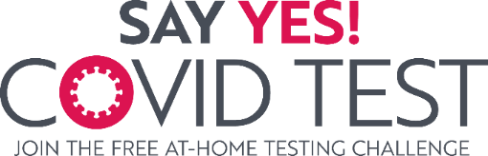

Key Messages
The ultimate goal of the public information campaign and testing initiative is to reduce community spread of COVID-19. By providing free, rapid at-home tests for COVID-19, we are putting power in the hands of individuals to be able to keep themselves, their family, and their community safe. Key messages include the safety, reliability, and availability of at-home tests in communities served. Another key message is to reference reliable science-based guidance from the Centers for Disease Control and Prevention and the U.S. Food and Drug Administration.

Example of Communication Channels, Timing, Frequency, & Evaluation
Channel | Say Yes! COVID Test Website
Audience | Potential and current participants in the testing initiative and research study, community residents, community leaders, media
Community specific? | Yes
Spanish translation? | Yes
Purpose/Goal | - Serve as a central point of information for all testing initiative details  - Facilitate test kit orders  - Encourage community participation and completion at-home testing  - Provide instructions on what to do with test results  - Introduce the optional research study opportunity  - Provide lay summary results from the initiative once available
Timing/Frequency | First communications channel
Measurement | Website visits, number of people directed to the test kit order site

Channel | Direct Mailer Postcard
Audience | All households in selected community
Community specific? | Yes
Spanish translation? | Yes
Purpose/Goal | - Introduce the testing initiative  - Provide a clear call to action  - Encourage visiting the website for more information and to sign up for the at-home testing challenge (order your test kits)  - Introduce the optional research study
Timing/Frequency | One time at start of campaign
Measurement | Number of postcards sent and delivered, website visits and number of people directed to the test kit order site

Channel | Social Media Toolkit
Audience | Local public health departments, community leaders, and community partners
Community specific? | Yes
Spanish translation? | No
Purpose/Goal | - Provide community leaders and partners with ready-to-use content, graphics, and videos to post on their existing social media channels  - Raise awareness of the testing initiative and encourage participation  - Drive traffic to the campaign website for more information and to sign up  - Remind participants to continue the at-home testing challenge throughout the campaign
Timing/Frequency | Throughout project
Measurement | Use of specific hashtag(s), number of posts and shares, social media−driven Say Yes! COVID Test website visits and other Google Analytics metrics (eg, time on site, bounce rate), community feedback
Channel | Posters
Audience | Potential participants in the testing initiative and research study, community residents
Community specific? | Yes
Spanish translation? | Yes
Purpose/Goal | - Introduce the testing initiative in a way that sparks interest, such as through appealing copy  - Provide a clear call to action to participate in the at-home testing challenge by ordering a test kit or picking up locally  - Intended for use around high-traffic areas
Timing/Frequency | Distributed with each bulk testing kit order; also available for download from the website for self-printing
Measurement | Number of posters distributed and downloaded

