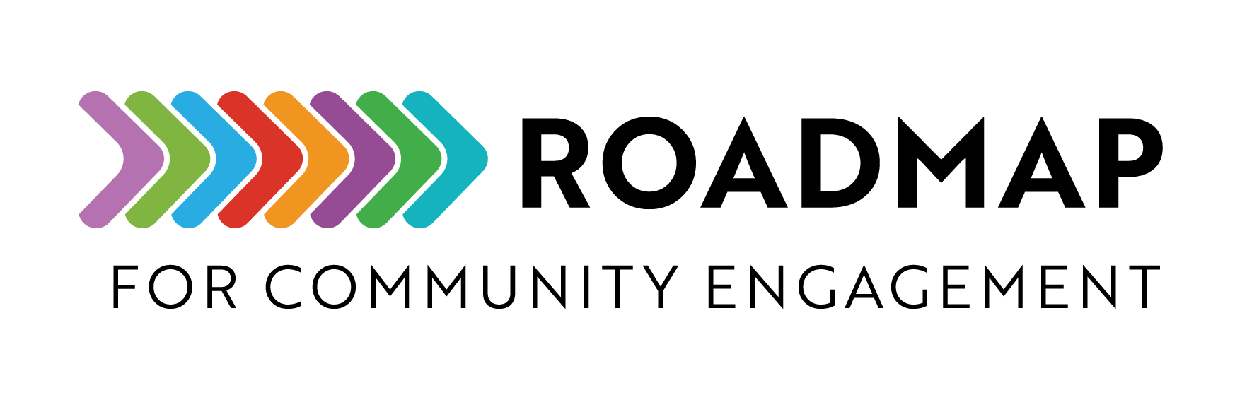

Communications Plan Template
This template allows you to fill in program-specific information to create a customized communications plan for a community-engaged program.
Instructions: Use the questions and suggestions in each section to help your team outline goals, audiences, messages, channels, and desired outcomes for program communications.
Add your own program name or logo to the cover page and remove this text box before sharing.

[Program/Organization name]
[year or project] Communications Plan

Contents
Program or Issue Summary 2
Audiences 2
Primary Audience 2
Secondary Audience 3
Tertiary Audience 4
Goals 4
Key Messages 5
Communications Strategy 7
Proposed Channels and Tactics 7
Addendum 9
Completed Tactics 9
Suggested Future Tactics 9

Program or Issue Summary
[Provide a summary of your program including a brief background. If your communications plan is intended to support your program as a whole, you should plan to review it regularly and make adjustments as needed.]
[If your program is already established and this communications plan is in response to a specific need, provide a brief summary of the considerations leading up to the current need, including the context and information on what has worked and what has not.]

Audiences
[Who do we want to reach?]
[Providing information about the people your communications need to reach will help to inform your messages and tactics. Use the questions below to start discussions about defining your program’s audiences. Revise or add other questions to fit the needs of your program.]
- Which populations are we hoping to reach? (ex: people with certain risk factors or health issues)
- What are the age ranges of the people we want to reach?
- Where are people located? (ex: geographic location, online community)
- Are there specific professional, community, or family roles they fill? (ex: community leaders, medical professionals, business owners, caregivers, teachers, parents)

[Which audiences take priority?]
[Once you have identified your program’s audiences, determine which are the most important to reach.]
- Primary audience
  - [List any demographic or relevant info]
- Secondary audience
  - [List any demographic or relevant info]
- Tertiary audience
  - [List any demographic or relevant info]

Primary Audience
[Include a short description of the audience based on the answers to the questions above.]

Primary Audience Demographics
[Customize the table below as needed to fit your program and complete the information for your primary audience.]

Secondary Audience
[Include a short description of the audience based on the answers to the questions above.]

Secondary Audience Demographics
[Customize the table below as needed to fit your program and complete the information for your secondary audience.]

Tertiary Audience
[Include a short description of the audience based on the answers to the questions above.]

Tertiary Audience Demographics
[Customize the table below as needed to fit your program and complete the information for your tertiary audience.]

Goals
[What are the most important things we need to accomplish and when?]
[Outline the top priorities for your program’s communications as specifically as possible and the timeline your plan will cover. Use the questions below to get your discussion started. Revise or add other questions to fit the needs of your program.]
[Your goals should focus on desired high-level outcomes rather than listing communications tactics or materials. (ex: “To identify and reach at least 10 community leaders within each Pennsylvania county in the next three months and help them disseminate information on the program’s emergency disaster preparedness website and resources to their residents.” or “To increase awareness of the program’s scholarship opportunities with high school students who are 16-18 years of age living in rural, lower-income communities in western Tennessee.”)]
- What are the most important things your program’s communications need to accomplish?
- When do these goals need to happen? (ex. in three months, by the end of this year)
- Are there any specific metrics you need to meet? (ex: “The program grant specifies that we must grow enrollment in the registry by at least 10% by November 30.”
[How will we define success?]
[For the goals you outline, identify what outcomes will mean that efforts have been successful. (ex: “Increasing the number of people who sign up for information at in-person events by 35% in the next six months.” or “Obtaining 150 new program participants from rural North Carolina counties in Q1.”)]

- [Include goal statement here]
  - [Successful outcome or metric to show how this will be measured]

- [Include goal statement here]
  - [Successful outcome or metric to show how this will be measured]

- [Include goal statement here]
  - [Successful outcome or metric to show how this will be measured]

- [Include goal statement here]
  - [Successful outcome or metric to show how this will be measured]

- [Include goal statement here]
  - [Successful outcome or metric to show how this will be measured]

Key Messages
[Based on the audiences and goals above, develop the key messages you need to communicate. Use the questions below to guide message development. Revise or add other questions to fit the needs of your program.]
[The message may vary slightly for different target audiences. (ex: “People living in rural Colorado counties who have been diagnosed with colorectal cancer can find helpful information about their condition, download resources, and connect with local support groups through our program website and newsletter.” vs “Oncology physicians and healthcare personnel in Colorado can use our program website to help connect patients with colorectal cancer to support services and other helpful resources.”)]
- What are the most important ideas you need to convey?
- Why should people in your primary audience be interested in your program?
- What are you hoping people will do?
- What important information or education will people receive?
- Is there anything people will receive that they are currently looking for? (ex: “People who are interested in participating in lupus research will learn about studies they may be able to take part in.”)

  - [Include key message statement here]

  - [Include key message statement here]

  - [Include key message statement here]

Communications Strategy
[How will you communicate your messages to your audiences?]
[To outline your communications strategy, you will need to decide which channels and tactics are most likely to reach your audiences and help achieve your goals. The term “channels” refers to the methods used to communicate with people like radio, social media, phone, or email. The term “tactics” refers to specific materials within a channel like a radio ad, Facebook post, printed brochure, or digital newsletter.]
[Refer to the demographic information for your audiences to determine where each audience is most likely to see or hear your messages. (ex: high school students may be active on a social media platform while older adults with a health concern may look for information online or from their local healthcare providers.]
[Other important factors to consider are your budget, timeline, and available resources.]
[What analytics or data will help to measure success?]
[Once you’ve determined which tactics are most likely to reach your audiences, outline the metrics you will use to define success for each tactic. These metrics will be your key performance indicators (KPIs). Although KPIs must support your goals, KPIs are tied to each tactic and are typically more specific than the higher-level metrics included in your goals. Some examples of KPIs include:]
- Number of new visitors/traffic to the website
- Number of people who joined a registry or attended an event
- Number of new followers or “likes” on social media

[The tables below provide some examples to help you plan channels, tactics, and KPIs to support your communications goals.]

Proposed Channels and Tactics
- [Include goal statement here]
  - [Successful outcome or metric to show how this will be measured (from “Goals” section above)]
Primary Audience | Channel/Tactic | KPIs/Analytics | Estimated Cost
Total Estimated Cost:

- [Include goal statement here]
  - [Successful outcome or metric to show how this will be measured (from “Goals” section above)]
Primary Audience | Channel/Tactic | KPIs/Analytics | Estimated Cost
Total Estimated Cost:

- [Include goal statement here]
  - [Successful outcome or metric to show how this will be measured (from “Goals” section above)]
Primary Audience | Channel/Tactic | KPIs/Analytics | Estimated Cost
Total Estimated Cost:

Addendum
[You can use this addendum to keep track of completed tactics and suggestions for the future.]

Completed Tactics
- [Example]
- [Example]
- [Example]

Suggested Future Tactics
- [Example]
- [Example]
- [Example]

