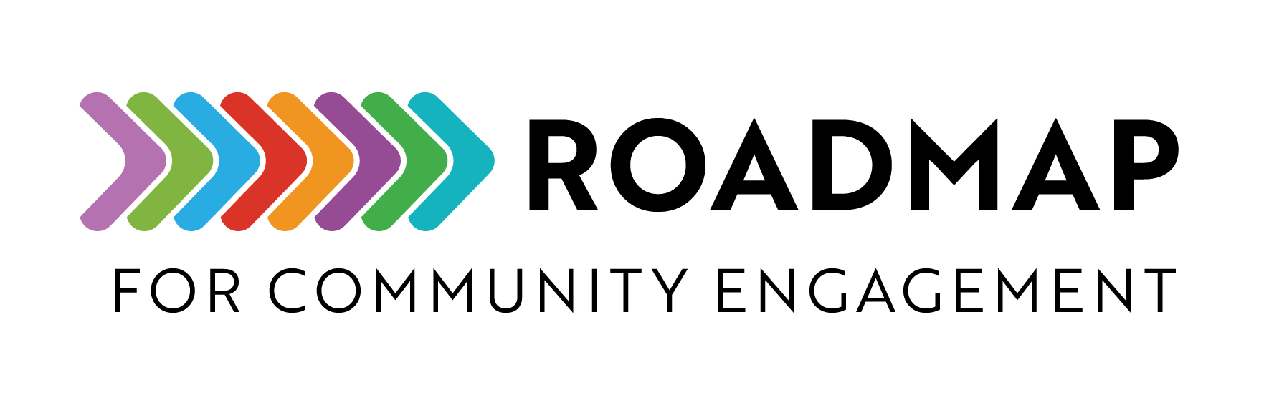

Community Partner Feedback Survey Example

This is an example of a feedback survey that you can use to understand community partners’ experiences with your program or events.

Instructions:
- Use this example to model your own feedback survey.
- Create easy-to-answer questions that will provide the type of information you are seeking to improve or track your program.
- Update the time it will take for participants to complete the survey.
- Distribute the survey using an electronic survey tool, paper copies, or email.

Add your own logo or other graphic and remove this text box before sharing.
Thank you for participating in the [Enter Program Name/Event Title]. The purpose of this survey is to get feedback on your experience. This survey is voluntary, and you can stop at any time. The survey should take about 5-10 minutes to complete.

Your feedback is essential to our goal of delivering high-quality programs. We will use the survey results to plan for future programs.

Please take a few minutes to provide your feedback.

PARTICIPANT INFORMATION
Please tell us about yourself:

First & Last Name:

Email:

Organization/Affiliation:

Organization Type (select all that apply)
- Nonprofit
- School/Education
- Health-based
- Social services
- Transportation
- Higher education/Research
- Emergency planning
- Fire/Police/Safety
- Mental health
- Other [if not listed please describe]

How did you learn about the program/event?
- Social media (e.g., Facebook, Instagram)
- Email invitation or newsletter
- Text message or phone call
- Flyer or poster in the community
- Other community organization
- School
- Church/Place of worship
- Word of mouth (friend, family, neighbor)
- Radio or podcast
- Television ad or news segment
- Newspaper or magazine
- Online search (e.g., Google, Bing)
- Community meeting or town hall
- Public service announcement
- Eventbrite or other event platform
- Other (please specify): ___________

PROGRAM/EVENT EVALUATION
Please rate the following aspects of the program/event. Rate your level of agreement on a scale of 1 (strongly disagree) to 5 (strongly agree) with the following statements:

- The program/event was easy to find and accessible.
- Strongly Disagree
- Disagree
- Neutral
- Agree
- Strongly Agree

- The program/event goals were clearly defined.
- Strongly Disagree
- Disagree
- Neutral
- Agree
- Strongly Agree

- The materials and resources provided were useful.
- Strongly Disagree
- Disagree
- Neutral
- Agree
- Strongly Agree

- The program/event was well organized.
- Strongly Disagree
- Disagree
- Neutral
- Agree
- Strongly Agree

- Communication before and during the program/event was clear.
- Strongly Disagree
- Disagree
- Neutral
- Agree
- Strongly Agree

- I felt supported during the program/event.
- Strongly Disagree
- Disagree
- Neutral
- Agree
- Strongly Agree

- My thoughts and ideas were listened to and acknowledged.
- Strongly Disagree
- Disagree
- Neutral
- Agree
- Strongly Agree

- Please provide your thoughts on your overall experience with the program/event.

- What did you like most about the program/event?

  - What did you like the least?

- Do you have suggestions on what could be improved?

- Please share any additional comments or reflections.

- Would you like to stay in touch with us for further program/event information?
- Yes
- No

ADVERTISING

- Which of the following [Program Name] advertisements were you aware of that helped drive community members to attend your event(s)?
- Facebook ads
- Instagram ads
- Television commercials
- Radio commercials
- Newspaper ads
- Direct contact (phone, e-mail)
- Word of mouth (friend, family, work)

- Please provide any comments to improve our advertising methods for future events:

DISTRIBUTION

- Please select your agreement: Within our organization, the distribution plan was effective.
- Strongly agree
- Agree
- Somewhat agree
- Somewhat disagree
- Disagree
- Strongly disagree

- Please list up to 3 steps within your distribution plan that were most successful in getting [list shared resource] to community members:

- Please list up to 3 steps within your distribution plan that you would change or eliminate in getting [list shared resource] to community members:

ACCESSIBILITY

- Please select your agreement: The Spanish version of the website was easy to find.
- Strongly agree
- Agree
- Somewhat agree
- Somewhat disagree
- Disagree

- Please select your agreement: It was easy for community members to obtain [list shared resource].
- Strongly agree
- Agree
- Somewhat agree
- Somewhat disagree
- Disagree

OVERALL

- Please select your agreement: Community members understood the program and why it is important.
- Strongly agree
- Agree
- Somewhat agree
- Somewhat disagree
- Disagree

- Please select your agreement: [Community Orgs/Leaders] provided excellent support to community partners during the program/event.
- Strongly agree
- Agree
- Somewhat agree
- Somewhat disagree
- Disagree

- Please list the 3 most beneficial aspects of the program/event for your community:

- Please list 3 aspects that could be improved upon for the program/event:

