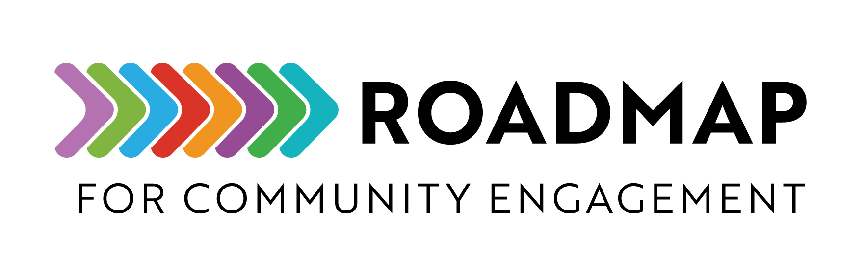

Community Pulse Survey

A Community Pulse Survey is a valuable tool for gathering insights from community members on issues that are important to them.

Instructions: Follow the steps below and use this template to create your survey.
- Deﬁne the Objective: Start with the end in mind. Consider first what you want to accomplish with a survey (e.g., gathering opinions on a new policy for a board meeting, assessing community needs for a grant).
- Keep it Short: Limit the survey to 5–10 concise questions to maximize response rates.
- Use Clear Language: Ensure questions are easy to understand and jargon free.
- Use Multiple Response Options: Use a mix of multiple choice, rating scales, and open-ended questions.
- Ensure Conﬁdentiality: Clearly state how responses will be used and personal information protected.
- Distribute: Share through methods such as email, social media, QR codes, and community networks.
- Analyze and Share Results: Use tools like Google Forms, SurveyMonkey, or Power BI to review responses and display ﬁndings. Share results with those who would like to receive them.

Add your own logo or other graphic and remove this text box before sharing.
Survey Title
[Create a concise title, e.g., "Community Perspectives on Affordable Housing"]

Short Introduction
[Thank you for participating in this survey. Your feedback will help shape community programs. This survey should take no more than 5 minutes to complete. All responses are conﬁdential.]

- What is your age group?
  - Under 18
  - 18–24
  - 25–34
  - 35–44
  - 45–54
  - 55+

- What is your primary connection to the community?
  - Resident
  - Business owner
  - Community worker
  - Other (please specify)

- How concerned are you about [Insert Topic, e.g., affordable housing] in your community?
  - Very concerned
  - Somewhat concerned
  - Neutral
  - Not very concerned
  - Not concerned at all

- What do you think are the biggest challenges related to [Insert Topic, e.g. affordable housing]? (Select all that apply)
- Lack of funding
- Government policies
- Community awareness
- Discrimination
- High costs
- Other, please specify ___________

- What solutions would you like to see implemented? (Open-ended)

- Would you like to be informed of the survey results?
  - Yes (please provide your email: )
  - No, I prefer to remain anonymous

- Any additional comments or suggestions? (Open-ended)

Thank You Message and Closing
[We appreciate your time and insights! Your feedback is valuable in shaping community actions. Stay tuned for updates on our efforts.]

