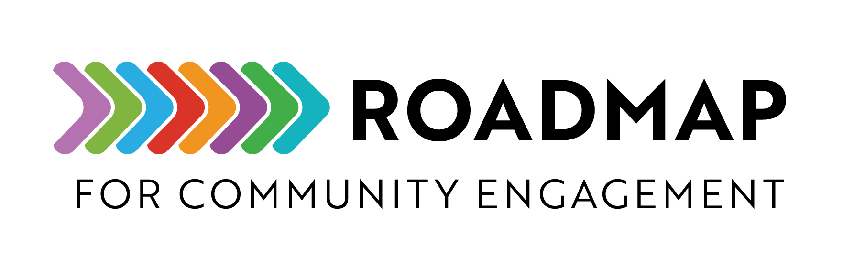

Preparing for Community Partnerships Checklist

This checklist helps foster community-engaged health research by sharing steps for collaborative partnerships.
Instructions: Review each item and discuss with partners about how to achieve each one.
Add your own logo or other graphic and remove this text box before sharing.
1. Build Partnerships
Bring together professionals, researchers, and community members to achieve a shared goal.
2. Create a Shared Vision
Work together to define the vision, mission, values, and goals of the health program.
3. Design Fair Partnership Practices
Develop policies that recognize different strengths and power dynamics, so everyone can contribute to the shared vision.
4. Be Clear About Purpose
Ensure all partners can explain the program’s purpose, goals, and the reason for engaging the community.
5. Share Respectfully
Exchange ideas and experiences while honoring different cultures, beliefs, skills, and viewpoints.
6. Use Plain Language
Provide information that is easy for everyone to understand.
7. Give Time to Prepare
Share materials early so all participants have time to review and prepare before meetings.
8. Offer Language Support
Plan for skilled interpretation and translation services, as needed.
9. Choose the Right Engagement Tools
Use methods that match the program’s goals, the community's needs, available time, and resources.
10. Check In Regularly
Review goals regularly to ensure they remain relevant and helpful for everyone involved.
11. Grow Together
Stay open to learning and improving as a team.

