[Organization or program name]
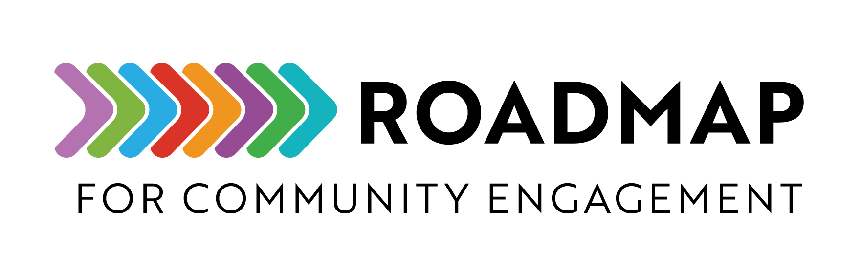

Image and Video Consent Form Template

This is a template you can customize to get written consent from participants to take and share photos or video recordings of program activities.
Instructions:
- Update the form with your program/organization’s name and information
- Give this form to the participant and obtain their signature for permission before the photo/video shoot
- File the signed, dated consent in a permanent folder where it can be located by the program leaders if needed.
Add your own logo or other graphic and remove this text box before sharing.

[Address]
Phone: [(xxx) xxx-xxxx]

CONSENT
\

I, ___________________________________________ , hereby consent to being photographed, videotaped, and or audio-recorded by [Organization or program name], its employees or designees, and I hereby grant to [Organization or program name] the royalty-free, exclusive perpetual right to use (and to license to others to use) my name, voice, image and likeness in any media whatsoever, for the following purpose or event:

which may include (check all that apply):

Videotape and/or audio record for classroom use

Educational teleconference

Non-commercial broadcast TV or radio broadcast

Commercial broadcast TV or radio broadcast

Broadcast, podcast or streamed on the internet

My signature certifies that I am 18 years of age or older, that I intend to be legally bound by this document, and that I have read, signed, sealed and delivered it voluntarily, without coercion and with knowledge of the nature and consequences thereof.

Signature | Date |  | Witness signature | Date
Printed name | Date |  | Witness printed name | Date

