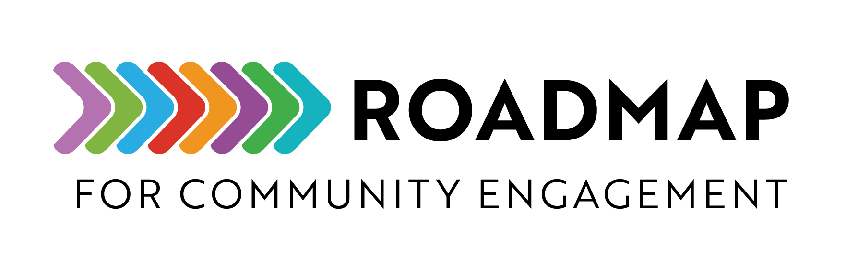

Program Planning Worksheet

The Program Planning Worksheet is a structured guide to help you outline and organize the fundamentals of your project.
Instructions: Work with your partners to discuss the following project elements and create a project plan.
Add your own logo or other graphic and remove this text box before sharing.

Program Title Here
Start with a clear and concise title that accurately reflects the program. Consider including community partners in the naming of the program.

Background and Needs
[Introduce the program and highlight any gaps that the program aims to address.]
[Clearly define why you are writing the proposal and tailor it to the audience's knowledge level and interests.]
[Support your proposal with accurate data, statistics, and credible sources.]
Need 1.
Need 2.
Need 3.

Proposal
[Clearly state what you are proposing to do.]

Goals
[Describe the goals of the program in a straightforward manner.]
Goal 1.
Goal 2.
Goal 3.

Membership
[Identify who will be involved in the program and their roles, such as, team members, steering committee, etc.]

Scope of Work
[Explain how the program team will achieve its goals, including the objectives for reaching each goal.]

Guiding Principles
[Outline the foundational values and standards that guide the program's execution and decision-making processes.]

Timeline
[Describe each step the program including when key objectives will be achieved.]
Item | Person/s | Completion Date
Example: Purchase gift cards at Walmart | Brenda Helper | July 1, 2025

Budget
[Develop a budget using the table below]
Item | Vendor (if applicable) | Cost
5 x $20 Gift Cards | Walmart | $100

