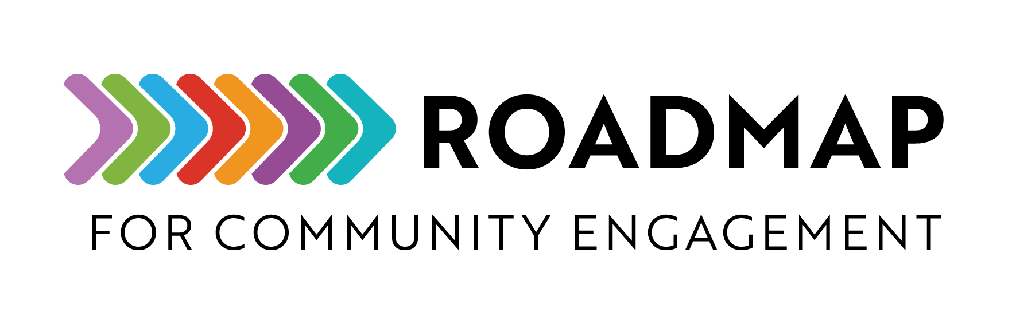
Program Reflection and Debrief Worksheet
This worksheet helps teams evaluate completed programs by capturing key insights on planning, goals, partnerships, costs, and communication. It’s designed to guide structured conversations, highlight successes, and identify areas for improvement.
Instructions: Use this document to capture lessons learned and shape stronger, more effective programs in the future with your partners.
Add your own logo or other graphic and remove this text box before sharing.

Program component | Questions for reflection
Planning | - Did our initial understanding of the problem or need match reality?  - Were our assumptions about resources, timelines, or participation accurate?  - What information or preparation would have made planning easier?  - Did we engage the right people early enough in the process?  - What would we do differently if we could plan this program again?
Goals | - Did we achieve the goals we set out at the start? Why or why not?  - Were the goals realistic and measurable?  - Did the program have unexpected outcomes (positive or negative)?  - How well did our goals align with the needs of participants or the community?  - What feedback from participants or partners best reflects whether we met our goals?
Partnerships | - Which partnerships contributed most to program success? Why?  - Were partner roles and expectations clear and upheld?  - How effective was our collaboration and communication with partners?  - Were there missed opportunities to involve other partners?  - How can we strengthen or expand these partnerships for future efforts?
Costs | - Did the actual costs align with our budget?  - Were resources used efficiently and responsibly?  - Did the program deliver sufficient value relative to its cost?  - What financial or in-kind contributions had the biggest impact?  - How can we better plan or track costs in the future?
Communication | - Were community members or partners kept informed throughout?  - Which messages or communication methods worked best?  - Did we reach all intended audiences effectively?  - How well did we listen and respond to feedback during the program?  - What communication lessons should we apply next time?
Next Steps | - What are the top lessons we should carry forward?  - How will we share what we’ve learned with others?  - Are there results here that are truly worth expanding or duplicating?  - What follow-up actions are needed with participants or partners?  - What’s the first step we should take to apply these insights to future programs?

Planning Reflection
- Did our initial understanding of the need/problem match reality?
____________________________________________________________________________________________________________________________________________________________________________________________________________________________________________________________________________________________________________________________________________________________________________________________________________________________________

- Were our assumptions about resources, timelines, or participation accurate?
____________________________________________________________________________________________________________________________________________________________________________________________________________________________________________________________________________________________________________________________________________________________________________________________________________________________________________________________________________

- What information or preparation would have made planning easier?
____________________________________________________________________________________________________________________________________________________________________________________________________________________________________________________________________________________________________________________________________________________________________________________________________________________________________________________________________________

- Did we engage the right people early enough?
____________________________________________________________________________________________________________________________________________________________________________________________________________________________________________________________________________________________________________________________________________________________________________________________________________________________________________________________________________

- What would we do differently in planning next time?
____________________________________________________________________________________________________________________________________________________________________________________________________________________________________________________________________________________________________________________________________________________________________________________________________________________________________________________________________________

Program Goals Reflection
- Did we achieve the goals we set at the start? Why or why not?
____________________________________________________________________________________________________________________________________________________________________________________________________________________________________________________________________________________________________________________________________________________________________________________________________________________________________________________________________________

- Were the goals realistic and measurable?
____________________________________________________________________________________________________________________________________________________________________________________________________________________________________________________________________________________________________________________________________________________________________________________________________________________________________________________________________________

- Did unexpected outcomes occur (positive or negative)?
____________________________________________________________________________________________________________________________________________________________________________________________________________________________________________________________________________________________________________________________________________________________________________________________________________________________________________________________________________

- How well did our goals meet the needs of participants/community?
____________________________________________________________________________________________________________________________________________________________________________________________________________________________________________________________________________________________________________________________________________________________________________________________________________________________________________________________________________

- What feedback best reflects whether we met our goals?
____________________________________________________________________________________________________________________________________________________________________________________________________________________________________________________________________________________________________________________________________________________________________________________________________________________________________________________________________________

Partnership Reflection
- Which partnerships contributed most to program success, and why?
____________________________________________________________________________________________________________________________________________________________________________________________________________________________________________________________________________________________________________________________________________________________________________________________________________________________________________________________________________

- Were partner roles and expectations clear and upheld?
____________________________________________________________________________________________________________________________________________________________________________________________________________________________________________________________________________________________________________________________________________________________________________________________________________________________________________________________________________

- How effective was our collaboration and communication with partners?
____________________________________________________________________________________________________________________________________________________________________________________________________________________________________________________________________________________________________________________________________________________________________________________________________________________________________________________________________________

- Were there missed opportunities to involve other partners?
____________________________________________________________________________________________________________________________________________________________________________________________________________________________________________________________________________________________________________________________________________________________________________________________________________________________________________________________________________

- How can we strengthen or expand these partnerships?
____________________________________________________________________________________________________________________________________________________________________________________________________________________________________________________________________________________________________________________________________________________________________________________________________________________________________________________________________________

Program Costs Reflection
- Did actual costs align with the budget?
____________________________________________________________________________________________________________________________________________________________________________________________________________________________________________________________________________________________________________________________________________________________________________________________________________________________________________________________________________

- Were resources used efficiently and responsibly?
____________________________________________________________________________________________________________________________________________________________________________________________________________________________________________________________________________________________________________________________________________________________________________________________________________________________________________________________________________

- Did the program deliver sufficient value for its cost?
____________________________________________________________________________________________________________________________________________________________________________________________________________________________________________________________________________________________________________________________________________________________________________________________________________________________________________________________________________

- Which contributions (financial or in-kind) had the biggest impact?
____________________________________________________________________________________________________________________________________________________________________________________________________________________________________________________________________________________________________________________________________________________________________________________________________________________________________________________________________________

- How can we better plan or track costs in the future?
____________________________________________________________________________________________________________________________________________________________________________________________________________________________________________________________________________________________________________________________________________________________________________________________________________________________________________________________________________

Communication Reflection
- Were community members or partners kept informed throughout?
____________________________________________________________________________________________________________________________________________________________________________________________________________________________________________________________________________________________________________________________________________________________________________________________________________________________________________________________________________

- Which messages or communication methods worked best?
____________________________________________________________________________________________________________________________________________________________________________________________________________________________________________________________________________________________________________________________________________________________________________________________________________________________________________________________________________

- Did we reach all intended audiences effectively?
____________________________________________________________________________________________________________________________________________________________________________________________________________________________________________________________________________________________________________________________________________________________________________________________________________________________________________________________________________

- How well did we listen and respond to feedback during the program?
____________________________________________________________________________________________________________________________________________________________________________________________________________________________________________________________________________________________________________________________________________________________________________________________________________________________________________________________________________

- What communication lessons should we apply next time?
____________________________________________________________________________________________________________________________________________________________________________________________________________________________________________________________________________________________________________________________________________________________________________________________________________________________________________________________________________

Team Next Steps
- What are the top lessons to carry forward?
____________________________________________________________________________________________________________________________________________________________________________________________________________________________________________________________________________________________________________________________________________________________________________________________________________________________________________________________________________

- How will we share what we’ve learned with others?
____________________________________________________________________________________________________________________________________________________________________________________________________________________________________________________________________________________________________________________________________________________________________________________________________________________________________________________________________________

- Are there results here that are truly worth expanding or duplicating?
____________________________________________________________________________________________________________________________________________________________________________________________________________________________________________________________________________________________________________________________________________________________________________________________________________________________________________________________________________

- What follow-up actions are needed with community members/partners?
____________________________________________________________________________________________________________________________________________________________________________________________________________________________________________________________________________________________________________________________________________________________________________________________________________________________________________________________________________

- What’s the first step to apply these insights?
____________________________________________________________________________________________________________________________________________________________________________________________________________________________________________________________________________________________________________________________________________________________________________________________________________________________________________________________________________

