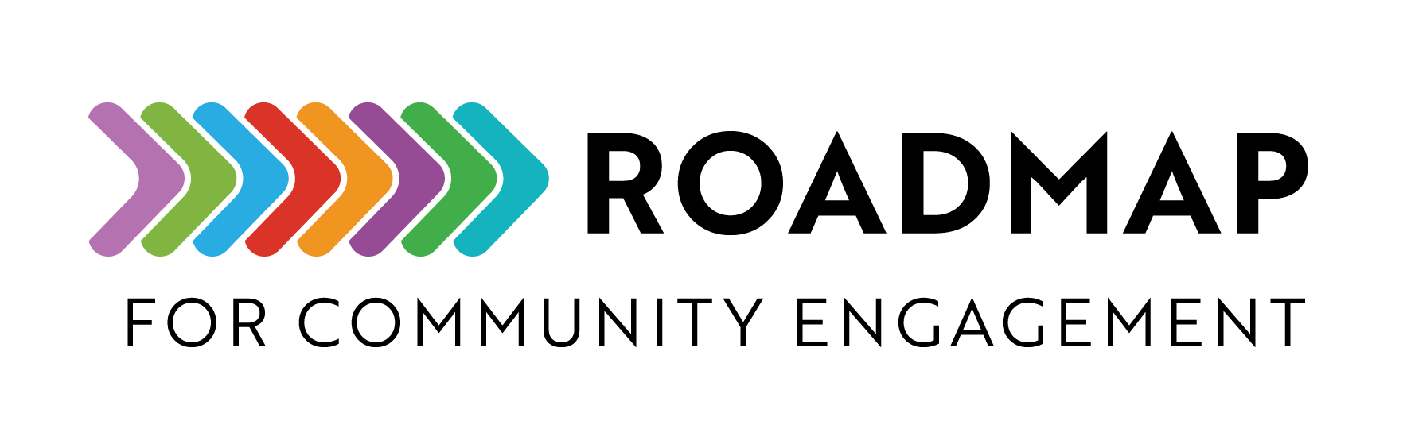
Strengths, Weaknesses, Opportunities, and Threats (SWOT) Analysis

A SWOT analysis is a strategic planning technique you can use to identify internal and external factors of your program and analyze them to inform decisions.
Instructions: Work with your partners to complete the SWOT analysis and discuss how to apply the information to help your program be successful.
Add your own logo or other graphic and remove this text box before sharing.

- Identify Strengths: List internal advantages, such as resources, expertise, or unique qualities.
- Identify Weaknesses: Recognize internal challenges or areas for improvement.
- Identify Opportunities: Highlight external factors that can benefit the program, like partnerships or funding.
- Identify Threats: Note external risks or challenges, such as policy changes or competition.

SWOT Analysis Grid

Strengths  Internal advantages and positive attributes | Weaknesses  Internal challenges or areas for improvement
Opportunities  External factors that can be leveraged | Threats  External risks that may impact success

