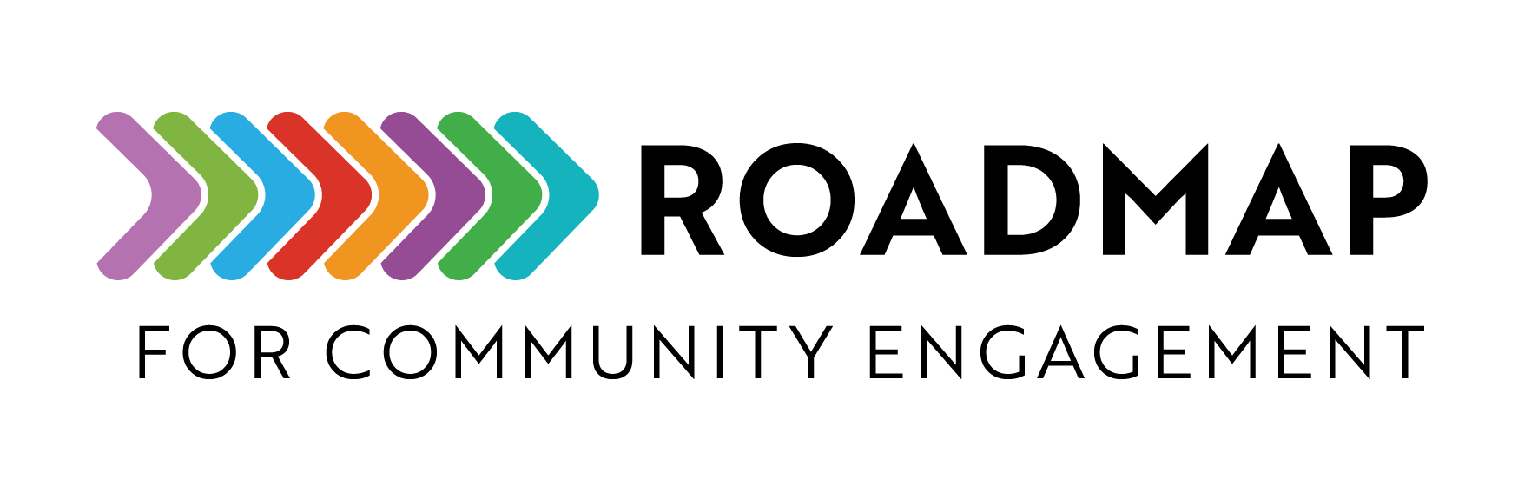

Social Media Platform Comparison

Use this document to evaluate which social media platforms might work best for your program to reach its intended audience. The table below covers popular social media platforms, but this space is continually evolving. The information was last updated September 2025.
Add your own logo or other graphic and remove this text box before sharing.

Platform | Purpose | Audience | Pros | Cons
Facebook | Sharing program updates and events, can help build community | Adults 30+, local communities and organizations | Wide reach among older demographics, group features for engagements, ad targeting options | Declining engagements among younger users, algorithm limits reach with ads
Instagram | Visual storytelling, outreach to younger audiences, engagement through images and videos | Young adults (18-34), visually engaged users | High engagement, strong storytelling potential | Limited text-based content, algorithm-driven visibility
LinkedIn | Professional networking, academic collaboration, promoting research findings | Researchers, academics, professionals, funders | Trusted platform for research dissemination, networking opportunities | Limited engagement from the general public, not ideal for informal community engagement
X (Twitter) | Quick updates, discussions, advocacy, engaging with researchers and policymakers | Professionals, researchers, activists, journalists | Real-time conversations, good for networking, hashtags boost discoverability | Character limit restricts depth, fast-paced nature can bury posts
TikTok | Short-form educational content, storytelling, youth engagement | Teens & young adults (16-30), visually engaged users | High virality potential, engaging for younger audiences, creative communication | High content turnover, requires frequent posting, time-intensive video creation
YouTube | In-depth educational content, webinars, program storytelling | All age groups, especially visual learners | Long-form content allows for detailed discussions, strong searchability | High production effort, requires consistent content strategy
Threads | Casual engagement, real-time discussions, researcher networking | Similar to X audience, early adopters, professionals | More informal discussions, less volatile environment than X | Limited adoption, algorithm still developing
Bluesky | Decentralized discussions, alternative to X, researcher and activist engagement | Early adopters, tech-savvy users, privacy-conscious communities | Less algorithm interference, decentralized control, growing engaged user base | Limited reach, still developing features, invite-only in some cases

