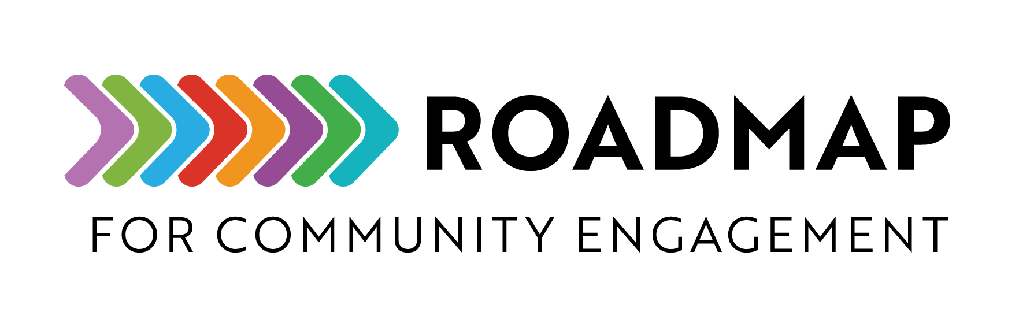
Workflow for Onboarding Partners to a Community Program or Initiative

This tool provides a detailed process to help identify community partners, integrate them into the program, and build a relationship that fosters long-term collaboration and growth.
Add your own logo or other graphic and remove this text box before sharing.
Workﬂow for Onboarding Partners to a Community Program or Initiative

Step 1:  Initial Outreach and Engagement | - Identify and connect with community leaders, groups, or organizations who are aligned with program goals  - Initiate conversations with potential partners via email, phone calls, or networking events  - Be prepared to share program overview, mutual benefits, roles, and expectations  - Schedule an introductory meeting with interested parties to discuss alignment and partnership opportunities  - Create a contact list with contact information for new partners
Step 2:  Confirm Interest and  Agreement Process | - Offer a simple and accessible interest form or collaboration proposal guide for partners to review  - Review submitted forms to ensure shared values, commitment, and mission alignment  - Conduct follow-up discussions to clarify objectives and expectations  - Co-develop a partnership agreement outlining roles, responsibilities, and commitments to be reviewed and signed by new partners/collaborators
Step3: Onboarding and Orientation | - Provide an onboarding packet with key program details, resources, and contacts  - Share tools, resources, and practices that support collaboration, transparency, and mutual accountability  - Host an orientation session covering:  - Program vision, goals, and impact  - Partner expectations and shared accountability practices  - Available support and resources  - Communication channels and key points of contact  - Description how partners/collaborators will be valued, supported, and compensated
Step 4: Integration and Collaboration | - Facilitate introduction among partners to foster trust and shared learning.  - Provide access to necessary tools, platforms, or training to help partners contribute meaningfully  - Elect a program liaison for ongoing support and guidance  - Establish regular check-ins for relationship-building, feedback sharing, and collaboration
Step 5:  Feedback, Monitoring,  and Support | - Set clear metrics and evaluation structures for partnership success  - Provide continuous training and resources to strengthen collaboration  - Create space for partners to share feedback to shape program direction and improve program effectiveness  - Recognize and celebrate partner contributions through spotlights, events, or awards
Step 6:  Long-Term Engagement and Growth | - Identify opportunities for deeper engagement and expanded collaboration  - Encourage knowledge sharing, community-led innovation, and spreading best practices among partners  - Regularly review partnership impact and adjust strategies as needed  - Offer invitation for sustained relationship building such as renewal or extension options for successful partnerships

